**Construction of circle:**

* **Construction of circle with given Diameter:**
* **Step 1:**

Identify the given value of the radius or diameter of the circle.

* **Step 2:**

Adjust the compass arms to the radius of the circle. Place the needle at the center of the circle and rotate the pencil arm 360∘ on the paper. You will get the circle of the given radius.

* **Construction through three non-collinear points:**
* To draw a circle passing through three non-collinear points, we need to locate the centre of a circle passing through 3 points and

its radius. Follow the steps given below to understand how we can draw a circle in this case.

**Step 1:**

Take three points P, Q, R and join the points shown below:

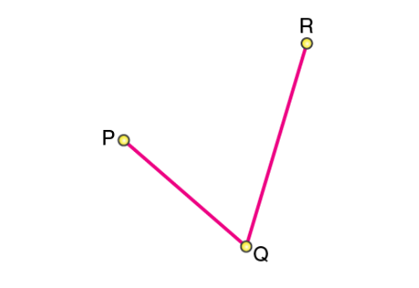

**Step 2:**

Draw perpendicular bisectors of PQ and RQ. Let the bisectors AB and CD meet at O such that the point O is called the centre of the circle:

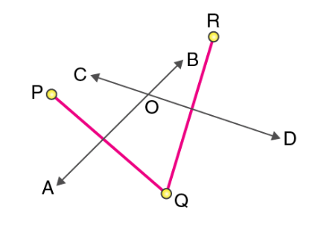

**Step 3:**

 Draw a circle with O as the centre and radius OP or OQ or OR. We get a circle passing through 3 points P, Q, and R:

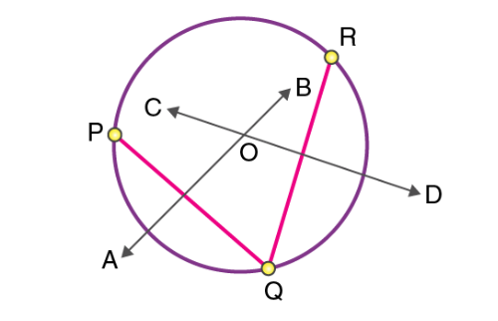

It is observed that only a unique circle will pass through all three points. It can be stated as a theorem, and the proof of this is explained below.

Given:

Three non-collinear points P, Q and R

To prove:

Only one circle can be drawn through P, Q and R

Construction:

Join PQ and QR.

Draw the perpendicular bisectors of PQ and QR such that these perpendiculars intersect each other at O.

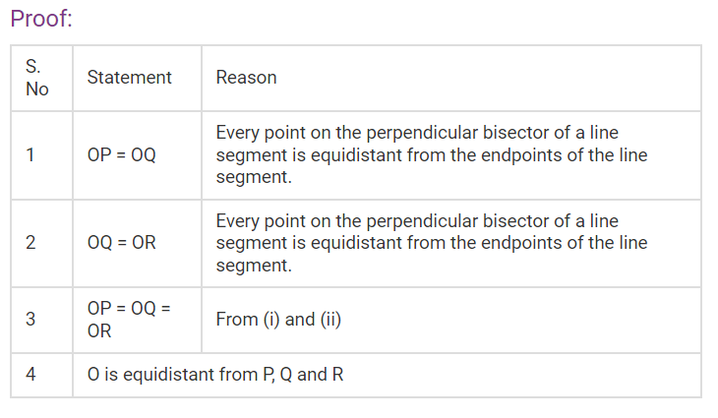

A circle is drawn with O as centre and OP as radius, then it will also pass through Q and R.

O is the only point which is equidistant from P, Q and R as the perpendicular bisectors of PQ and QR intersect at O only.

Thus, O is the centre of the circle to be drawn.

OP, OQ and OR will be radii of the circle.

From above it follows that a unique circle passing through 3 points can be drawn given that the points are non-collinear.

Till now, you learned how to draw a circle passing through 3 non-collinear points. Now, you will learn how to find the equation of a circle passing through 3 points. For this we need to take three non-collinear points.

(Tayyab 14209)